BSC – HGP – Project Go

UI Design Document & Report

# Division of Work

Student Name1: Student Number1:

Student Name2: Student Number2:

Student Name3: Student Number3:

Please complete the sections below with regard to the estimate of the division of work between the two partners

If the work was split in the range of 45% to 55% per partner, then that is fine and simply say “Work was evenly divided”. If this was not the case, then state with a summary sentence. This is the important statement of this file.

Division of work: work was evenly divided ______________________________________________________________________

## Code repository log (if applicable)

Paste here

## Percentage of work completed by each partner on each class / task

Some areas require more work than others so this is only for reference. An average of these values will not be calculated.

|  |  |  |  |
| --- | --- | --- | --- |
| **Filename / Task** | **Student Name 1** | **Student Name 2** | **Student Name 3** |
| GoBoard | 40% | 30% | 30% |
| Filename 2 | 20% | 45% | 35% |
| System design | Etc. |  |  |
| Git hub repository |  |  |  |
| Learning rules of draughts |  |  |  |
|  |  |  |  |

# UI Design

**Submission:** Edit this template and submit it as part of your submission.

**Length**: Should be 4 pages approx. Word count is flexible, but all decisions should be clarified.

To achieve good marks in this item ensure that this document is well structured and addresses each of the following headings and subheading. The explanation of each UI Design Choice should be clear, precise and show substantial consideration has been made, references are welcome. All decisions should be explained regardless of how basic they are. Do not cut and paste justification from the internet (plagiarism) or notes but include references and explanations in your own words where appropriate.

**Student Names:** FirstName LastName

* Include multiple screen shots of the application each focusing on a different component clearly labelled
* Clearly indicate what is working and what is not.
* Discuss each component under the following headings
* Location: e.g. The button was placed in the bottom right to as it is the default location to confirm and action
* Colour: The colour scheme was chosen to avoid the main form of colour blindness and produce high contrast for the visually impaired.
* Size:
* Style:
* Etc.

**N.B.** Clearly mention any additional features here either visual or functional so that appropriate marks are awarded

## Winning Screen

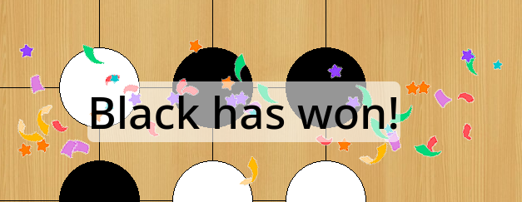Figure 1: Winning Screen

As you can see in Figure 1, the winning screen shows the winner of a Go match. As the label, which shows the winner, is placed over the finished Go board, semi transparent white background is placed behind the label, to make the black text visible against the black stones.

There is also a confetti animation, to make clear, that the game has ended and a winner was determined and to make the winning screen more appealing.

# Screen Shots of Working/Not Working Features

**N.B. Be sure to comment what is working and not working for each of the tasks. The boxes should be expanded to contain the content.**

All code should be testable where possible and error message should be displayed to show where code has failed.

|  |
| --- |
| **Task 1 (1 image with description + what is working/not working)** |
|  |

|  |
| --- |
| **Task 2 (6 images of working Menus/buttons/Labels including description + what is working/not working)** |
|  |

|  |
| --- |
| **Task 3 (2 images + what is working/not working)** |
|  |

|  |
| --- |
| **Task 4 (2 images + what is working/not working)** |
|  |

|  |
| --- |
| **Task 5 (2 images + what is working/not working)** |
|  |

|  |
| --- |
| **Task 6 (2 images + what is working/not working)** |
|  |

|  |
| --- |
| **Task 7 (2 images + what is working/not working)** |
|  |

|  |
| --- |
| **Task 8 (2 images + what is working/not working)** |
|  |

|  |
| --- |
| **Task 9 (2 images + what is working/not working)** |
|  |

|  |
| --- |
| **Task 10 (2 images + what is working/not working)** |
|  |

|  |
| --- |
| **Task 11 (2 images + what is working/not working)** |
|  |

|  |
| --- |
| **Task 12 (2 images + what is working/not working)** |
|  |